John Winthrop

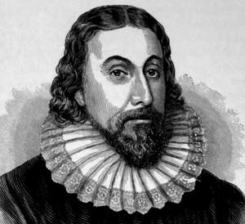
In the year 1588, the British Royal Navy inflicted a decisive and devastating defeat upon the Spanish Armada. Because of this, Protestant Britain would rule the seas; Catholic Spain was reduced to a second-string European power. The year of England's ascendancy also marked the birth of John Winthrop, born into a prosperous middle-class family in England.
As a young man, Winthrop became convinced that England was in trouble: Inflation coupled with population growth had led men to pursue wealth at the cost of their souls. Efforts to reform the Church of England had faltered. Zealous bishops hounded religious dissenters who resisted obeying the rules. Puritans like Winthrop were persecuted. As he worried about his future, Winthrop became intrigued by a new venture, the Massachusetts Bay Colony, a commercial enterprise that offered the chance for religious freedom in the New World.
Winthrop struggled with the decision to abandon his homeland. He was aware that hardships had claimed the lives of half the Pilgrims who had settled in Plymouth 10 years earlier. He had no illusions about the difficulties that lay ahead -- a hostile climate, bad food, sickness and isolation. When he survived a bad accident with his horse, he took this as a divine signal: God was calling him to create a holy community in the wilderness of New England.
Winthrop was chosen to serve as governor of the fledgling Puritan colony. Before leaving England, Winthrop delivered a sermon titled "A City Upon a Hill." Reminding them of their promise with God, he urged his fellow travelers to honor their duties and obligations, "or surely we shall perish." Yet underlying this warning was a message of hope. Drawing upon the book of Deuteronomy, he concluded, "Let us chose life that we, and our children may live, by obeying His voice, for He is our life and our prosperity." And so Winthrop and his fellow Puritans sailed westward to establish a model Christian commonwealth they hoped would serve as an example that England and all of Europe would one day adopt.
In Boston, Winthrop assumed leadership of the colony. His energies seemed remarkable and limitless. Whatever needed doing, he tried to do it. Repeatedly elected governor, he was chiefly responsible for maintaining civic and social order. Political unity demanded religious conformity. Yet Winthrop understood that a measure of dissent and disagreement was inevitable. By his nature, he was a moderate, inclined to seek compromise, as he did when his friend Roger Williams began testing the patience of the authorities. At the same time, Winthrop recognized there were limits to dissent, for challenges to religious authority could undermine political order and social stability. Roger Williams was eventually banished, and when Anne Hutchinson tested those limits, Winthrop took action. Hutchinson, too, was banished from Massachusetts for the rest of her life.

